EXCEL PROJECT:

Retail Analysis Walmart Superstore Dashboard:

ATHARV VIRENDRA WAGHMARE

Dashboard-File-Link:

https://docs.google.com/spreadsheets/d/1aes9a1f5yKxNsEyuhR1STZr7e-iQqshy/edit?usp=sharing&ouid=103214557259220708096&rtpof=true&sd=true

|  |  |  |  |  |  |  |
| --- | --- | --- | --- | --- | --- | --- |
| **Walmart Superstore Dataset** | | | | | | |
|  |
|  |
|  |  |  |  |  |  |  |  |
| **Dataset Description** | | | | | | |  |
|  |
|  |  |  |  |  |  |  |  |
| **Row ID** | | **A unique identifier assigned to each row of data.** | | | |  |  |
| **Order ID** | | **The unique identifier assigned to each sales order.** | | | |  |  |
| **Order date** | | **The date on which the sales order was placed.** | | | |  |  |
| **Ship date** | | **The date on which the order was shipped.** | | | |  |  |
| **Ship Mode** | | **The mode of shipment used for the order.** | | | |  |  |
| **Customer ID** | | **The unique identifier assigned to each customer.** | | | |  |  |
| **Customer Name** | | **The name of the customer who placed the order.** | | | |  |  |
| **Segment** | | **The market segment to which the customer belongs.** | | | |  |  |
| **City** | | **The city where the order was shipped.** | | |  |  |  |
| **State** | | **The state where the order was shipped.** | | |  |  |  |
| **Country** | | **The country where the order was shipped.** | | | |  |  |
| **Postal Code** | | **The postal code of the shipping address.** | | |  |  |  |
| **Market** | | **The market in which the order was placed.** | | | |  |  |
| **Region** | | **The region in which the order was placed.** | | | |  |  |
| **Product ID** | | **The unique identifier assigned to each product.** | | | |  |  |
| **Category** | | **The category to which the product belongs.** | | | |  |  |
| **Sub-Category** | | **The sub-category to which the product belongs.** | | | |  |  |
| **Product Name** | | **The name of the product.** | |  |  |  |  |
| **Sales** | | **The total sales revenue generated by the order.** | | | |  |  |
| **Quantity** | | **The quantity of the product ordered.** | | |  |  |  |
| **Discount** | | **The discount applied to the order.** | | |  |  |  |
| **Profit** | | **The profit margin generated by the order.** | | | |  |  |
| **Shipping Cost** | | **The cost of shipping the order.** | | |  |  |  |
| **Order Priority** | | **The priority assigned to the order.** | | |  |  |  |

**Objective:**

To conduct a comprehensive retail analysis of Walmart Superstore's sales and profitability, aiming to develop a dynamic dashboard that furnishes actionable insights for strategic decision-making and operational optimization.

**Key Features of the Dashboard**:

* **Identifying Key Performance Indicators (KPIs) with Sparklines:**

Utilize Sparklines to visually represent crucial KPIs such as total sales revenue, profit margin, sales growth rate, and average transaction value. This facilitates quick insights into performance trends at a glance.

* **Analysing Sales and Profitability Across Different Dimensions:**

Segment sales and profitability data by customer segments, product categories, markets, and regions. This segmentation allows for the identification of trends and optimization opportunities, aiding in targeted decision-making.

* **Identifying Top-Performing and Underperforming Categories:**

Analyse sales and profitability metrics to pinpoint top-performing product categories driving revenue and profitability. Concurrently, identify areas of underperformance to strategize targeted improvement efforts for enhancing overall performance.

* **Visualizing Geographic Distribution and Market Share:**

Visualize the geographic distribution of sales and market share to identify growth opportunities and potential expansion areas in different regions. This visualization aids in understanding regional dynamics and facilitates informed decision-making regarding market penetration and resource allocation.

* **Understanding Contribution of Different Sub-Categories:**

Analyse the contribution of various sub-categories to overall sales to comprehend product preferences and optimize inventory management and marketing strategies accordingly. This granular analysis enables precise targeting of efforts for improvement and optimization.

* **Evaluating Market Share by Region:**

Evaluate market share by region to inform strategic decisions pertaining to resource allocation, expansion strategies, and market penetration efforts. This assessment aids in understanding regional competitiveness and guides decisions regarding market entry or expansion.

* **Estimating Category & Sub-Category Wise Metrics:**

Generate category and sub-category-wise metrics to provide detailed insights into performance at a granular level. This detailed analysis facilitates the identification of specific areas for improvement and enables targeted actions to drive overall performance enhancement.

By incorporating these key features into the dynamic dashboard, stakeholders gain access to actionable insights that empower informed decision-making and facilitate operational optimization for sustained growth and success in the competitive retail landscape.

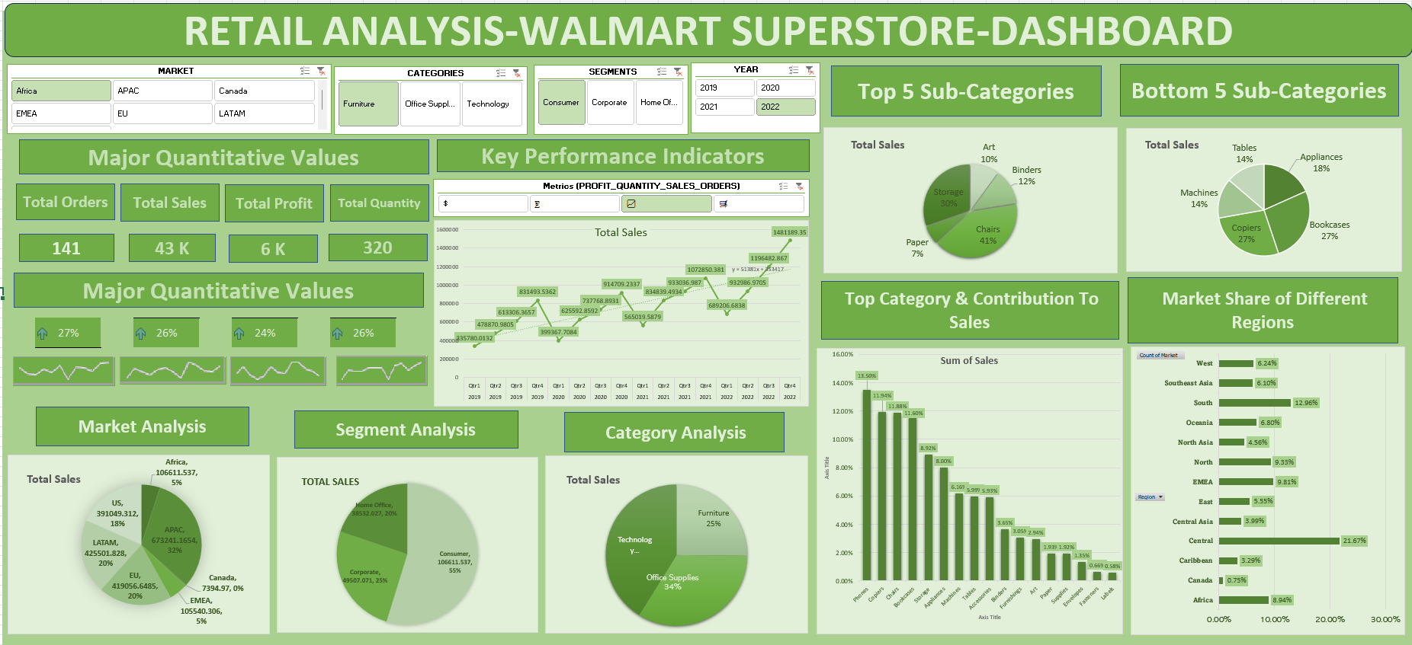

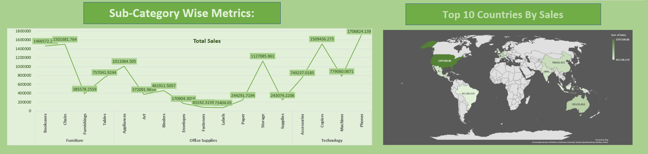

**Conclusion:**

In summary, the deployment of a dynamic dashboard for retail analysis of Walmart Superstore's sales and profitability offers invaluable insights for strategic decision-making and operational optimization. Leveraging key features such as visualizing KPIs, segmenting data across different dimensions, identifying top-performing and underperforming categories, and evaluating market share by region, stakeholders gain a comprehensive understanding of the store's performance landscape.

This dashboard facilitates swift identification of trends, opportunities, and areas needing improvement, empowering decision-makers to take targeted actions to enhance revenue, profitability, and market competitiveness. With detailed insights into customer segments, product categories, and geographic distribution, Walmart can refine its inventory management, marketing strategies, and expansion efforts effectively.

By estimating metrics at both category and sub-category levels, the dashboard enables granular analysis, ensuring no valuable insights are overlooked. Ultimately, this data-driven approach fosters agility and informed decision-making, positioning Walmart Superstore for sustained growth and success in the dynamic retail landscape.